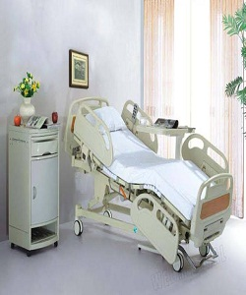

Hospital bed

$228.75

Availability: In stock

**Description:**

The hospital bed, part of the Profine Collection, is designed with a lavish modern style in premium linen upholstery. Ribbed tufted headboard and additional metal legs to ensure stability and support.